Sample Solutions
COS 226 – Final Exam – Spring 2009
1. MST (8pts)
- 4,9,18,19,21,22,23,30
- 18,23,21,19,30,4,9,22

2. KMP (5pts)
    - A B A B A C C B A
    - W: 0 X: 5 Y: 1 Z: 4
    - 3. Mystery Code (5pts) Answer: d
    - 4. Acronyms (8pts) SAT: g (a logic problem) KMP: c (substring-search algorithm) NFA: h (basis for grep) DFA: a (basis for KMP algorithm) DFS: d (fundamental recursive method) BFS: e (for single source shortest path in unweighted graphs) PFS: b (general graph searching scheme) NP: f (set of all problems checkable in polynomial time)
    - 5. LZW compression (4pts)

1. Answer: c (square root of N)
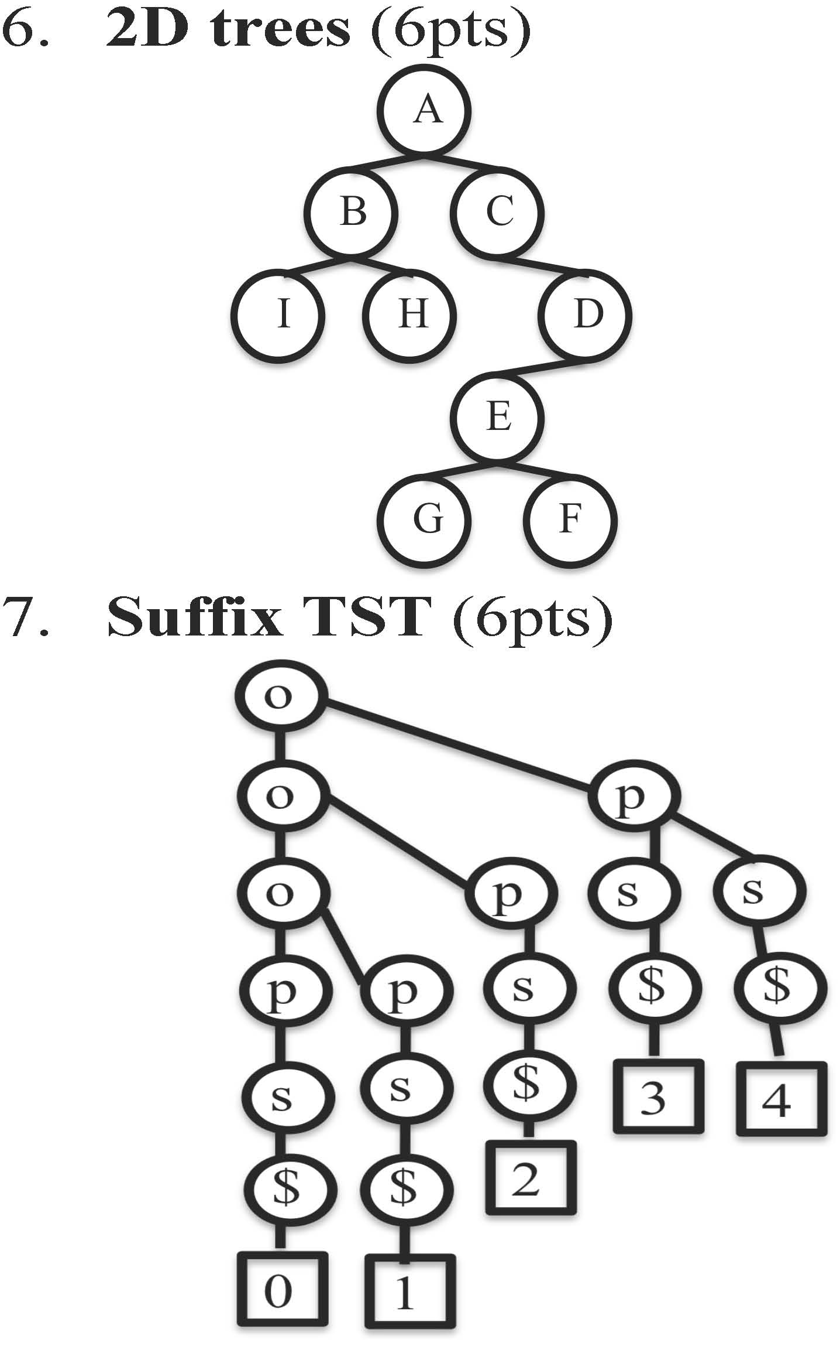
8. String symbol table (7 pts) M-ary trie: b BST: a,c,d TST: a,b
Red-black tree: a,c
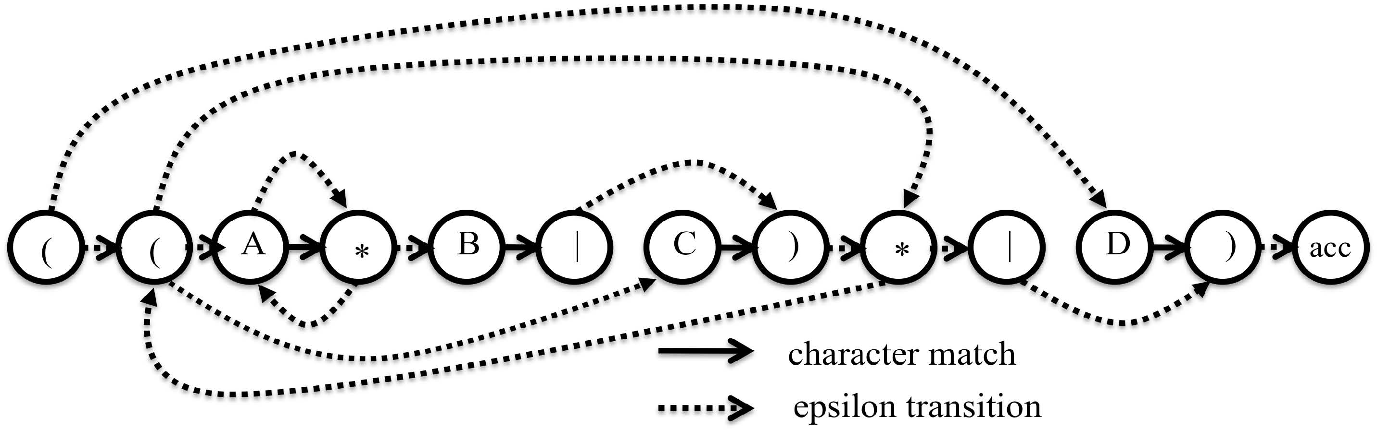
- RE pattern matching II (4pts) Answer: a
- 7 sorting algorithms (14 pts) Answer: g, c, b, d, f, e, a
- Convex hull

Next points; current hull A; A G; A G C; A G C H; A G C H I; A G I F; A G F B; A G F B D; A G F D E; A G F E
13. Strong Components (3pts)
- First component: A, B
- Second component: C
- Third component: D,E,F,G

14. Reduction (4pts)
1. Answer: d (Promote them all)
- Huffman encoding (4pts)
- Hard problem identification (9 pts)

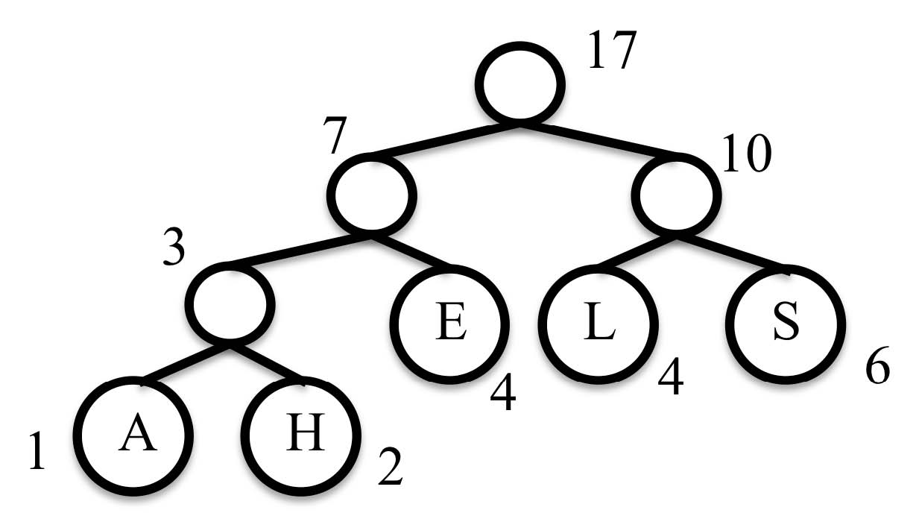
1. Answers: A,B,C,E,G

